HARVELELECTRIC ELECTRONIC STORE

# 

# Itel 32" Inches A32100AE HD TV With Overvoltage Protection

Brand: [Itel](https://www.jumia.com.ng/itel/)

**Price: $2780**

Was ~~$3000~~ 54%

+ shipping only for V.V.I.P clients.

## **Product details**

**Itel A32 HD TV with Overvoltage Protection**is a classy frameless TV made just for you. The 20 watts stereo sound makes you feel like you are in a cinema. You get to hear and enjoy quality sounds from movies and music of your choice.

The over voltage protection feature ensures that your TV isn't destroyed by high voltage (or high current). With the USB media player, you can play any media in your flash or pen drive on your TV.

Unlike the panels of most TVs in the market, this TV has A+ Grade Original Panel. This means that the panel is of the highest quality you can get in the market and so you won’t have to keep going in and out of a TV repairer’s shop to fix it. In fact, when you buy this TV, you are buying peace of mind.

Warranty is 12 Months

Redeem your warranty in any CarlCare  Center across Nigeria.

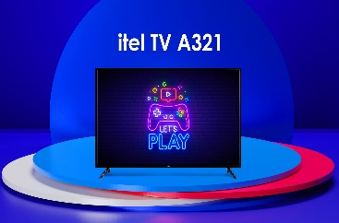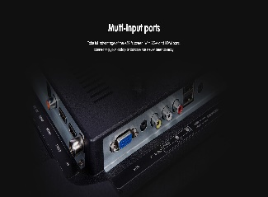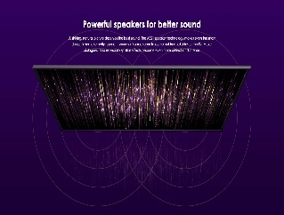

## **Specifications**

## **KEY FEATURES**

* Frameless design
* OD 22 Thickness
* Metal body
* Power CPU & GPU
* Build-in Stabilizer
* A+ Grade Original Panel
* Simplified UI & OSD Design
* Enjoy videos/MP3/Pictures USB Flash
* HD 1366*768
* Built in 2*10W Speaker
* Narrow Bezel Design
* Overvoltage Protection
* iCast TV

## **WHAT’S IN THE BOX**

* **Itel A32 HD iCast TV**
* Manual
* Stand and Screw
* Remote control
* Batteries

## **SPECIFICATIONS**

* **SKU**: IT724EA0H4WBNNAFAMZ
* **Product Line**: Itel Official Store
* **Model**: Itel A32100AE
* **Production Country**: China
* **Size (L x W x H cm)**: 76.5X10X48.8
* **Weight (kg)**: 3.7
* **Color**: Black
* **Main Material**: Metal body
* **Shop Type**: Harvel Electric Store